Please circle/tick/insert your answer for each question below.
Total marks = 45, Pass rate = 36 (80%)

1. |  | Please put the following steps in order, when acting as chief/referee at a league match that you would undertake for the event (1 mark)
 | 1 | Checking event site/track/equipment
 | 2 | Creating a Duty sheet
 | 3 | Conducting a briefing for officials in the discipline
 | 4 | Reporting to the Meeting Manager / organiser to sign in
 | 5 | Receiving information / timetable
 | A | 5,2,4,1,3
 | B | 5,2,1,3,4
 | C | 2,5,3,4,1
 | D | 5,2,1,4,3

2. |  | How long before the meeting would you report in, as chief/referee for a league match? (1 mark)
 | A | No specified time
 | B | Minimum of 30 minutes prior to first event
 | C | Minimum of 1 hour prior to first event
 | D | Minimum of 2 hours prior to first event

3. |  | What things would you include in your briefing as chief/referee, to officials at the start of the day of a league match? (4 marks)
 | A | Rules the meeting is operating under
 | B | Provide a list of refreshments available for officials to choose from
 | C | Number of copies of start lists / field cards for events/judges
 | D | Health & Safety briefing
 | E | Check officials are comfortable with allocated duties and or if they require support or mentoring

4. |  | With whom do you need to liaise with before the event gets under way in your role as chief/referee at a league match? (6 marks)
 | A | Chief Photo-finish Judge
 | B | Chief Starters Assistant
 | C | Field Referee
 | D | Meeting Manager / Organiser
 | E | Technical Manager (if appointed)
 | F | Track Referee
 | G | Chief Call Room (if appointed)

5. |  | You are appointed the Start Co-ordinator (SC) at a Regional Championships. What tasks would you undertake before the competition starts (select all that apply) (13 marks)
 | A | Liaise with the SAs
 | B | Liaise with The Chief Starters Assistant
 | C | Prepare a duty sheet for the day
 | D | Check any timetable changes
 | E | Check any changes in number of heats
 | F | Liaise with the Call Room Manager
 | G | Liaise with the Chief Timekeeper
 | H | Liaise with the Track Referee
 | I | Liaise with the Photo finish Chief
 | J | Liaise with the Meeting Manager
 | K | Walk the track to establish Starting positions
 | L | Check refreshment provision
 | M | Liaise with the Field Referee
 | N | Perform a zero-control test
 | O | Liaise with the Clerk of Course
 | P | Agree a time for the Zero Control Test
 | Q | Liaise with the ground staff re starting blocks/lane markers and their transportation
 | R | Check the heights and weights of any hurdles/barriers to be used
 | S | Collect a radio for communication
 | T | Liaise with ground staff re Starting rostrum and its transportation
 | U | Check the Electronic Starting system is working.

6. |  | You are the Start Coordinator (SC) at a Regional Championships with a team of two other Starters (but no Start Referee). How would you allocate Start duties to the team? (1 mark)
 | A | By alternating starts within the Start team regardless of the type
 | B | By giving all middle-distance races to the least experienced member of the team
 | C | By allocating all short sprint races to yourself and equitably spreading the remainder to your team
 | D | By allocating the most difficult starts to yourself and equitably spreading the remainder to you all

7. |  | You are the Start Coordinator (SC) at a County Championships, you will therefore need to brief the team before the meeting starts. Which option best explains how the briefing will take place? (1 mark)
 | A | By emailing your team a copy of your briefing in advance of the meeting
 | B | By holding a joint briefing with the Starters Assistants where the Chief Starters Assistant takes the lead
 | C | By holding a briefing meeting with the Starters as soon as you can gather them together
 | D | By holding a briefing meeting with the SAs and Starters where you take the lead before following on with your Start team

8. |  | You are appointed as a Starter at a County Championships. You are the Starter for a 100m start for U17 men and you recall the race because you consider the athlete in Lane 5 has false started. How would you deal with this? (1 mark)
 | A | Immediately instruct the Starters Assistant to disqualify the athlete
 | B | Wait for the athletes to return to the start and line up, then instruct the Starters Assistant to show a red card to the athlete in Lane 5
 | C | Wait for the athletes to return to the start and line up before announcing the athlete in Lane 5 is disqualified
 | D | Wait for the athletes to return to the start and line up before advising the athlete in Lane 5 to wait for the gun and ask for a green, no warning, card to be shown

9. |  | You are a Starter at a County Championships and on recall duty for a 100m start. As the Starter fires the gun you believe the athlete in Lane 3 had already moved out of the set position, but the Starter does not recall the race. What would you do? (1 mark)
 | A | Having given the Starter time to recall, you recall the race
 | B | Attract the Starter’s attention to a possible False Start
 | C | Assume you were wrong and there was not a False Start
 | D | Assume the Starter had seen it and had chosen not to recall it, so you take no action.

10. |  | In the above scenario you were the Starter (also the Start Co-ordinator) and the race was recalled by your Recaller. How would you deal with this? (1 mark)
 | A | You consider there was no False Start and so simply line the athletes up again for a restart
 | B | Discuss with the Recaller their reason for recalling the race and if you agree announce the appropriate sanction (Warning Card or DQ), if you disagree ask for a Green Card to be shown
 | C | Discuss with the Recaller their reason for recalling the race and if you disagree overrule them and give no sanction
 | D | Discuss with the Recaller their reason for recalling the race and even though you disagree you award a sanction (Warning Card or DQ)

11. |  | You are the Starter at a Regional Championship and are the Starter for a Senior Men’s 100m. The athlete in Lane 7 starts fractionally before the noise of the gun, you also noticed that the athlete in Lane 8 had significantly twitched just before Lane 7 had started. You recall the race – what action would you take? (1 mark)
 | A | Disqualify the athlete in Lane 7 because their hands and/or feet had lost contact with the ground
 | B | Disqualify the athletes in both Lane 7 and 8
 | C | Disqualify the athlete in Lane 8 because they twitched
 | D | Issue a Conduct Warning to the athlete in Lane 8 because as the starter you deemed the athlete had twitched causing the False start

12. |  | In the above scenario under what rule would you take your action? (1 mark)
 | A | TR 16.7.1
 | B | TR 16.5.3
 | C | TR 16.5.1
 | D | TR 16.8

13. |  | If the twitch had been made by the athlete in Lane 2 (not Lane 8) what action would you take? (1 mark)
 | A | Disqualify the athlete in Lane 7 because their hands and/or feet had lost contact with the ground and movement in lane 2 had not had an effect
 | B | Disqualify the athletes in both Lane 7 and 2
 | C | Disqualify the athlete in Lane 2 because they twitched
 | D | Issue a Conduct Warning to the athlete in Lane 2 because they caused the False Start

14. |  | You are on the Start Team for a Regional Indoor Championships where a Start Information System (SIS) is in use. What do the following SIS Print Outs tell you? Select all that apply. (2 marks) | 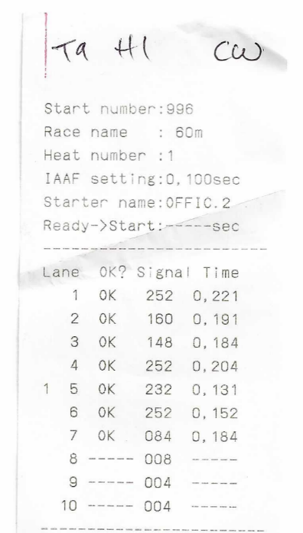
 | A | All the athletes had a fair start
 | B | Lane 5 had the fastest reaction
 | C | Lane 1 had the fastest reaction
 | D | Lane 5 False Started

15. |  | Looking at this second read out. What does this SIS information tell you? (1 mark) | 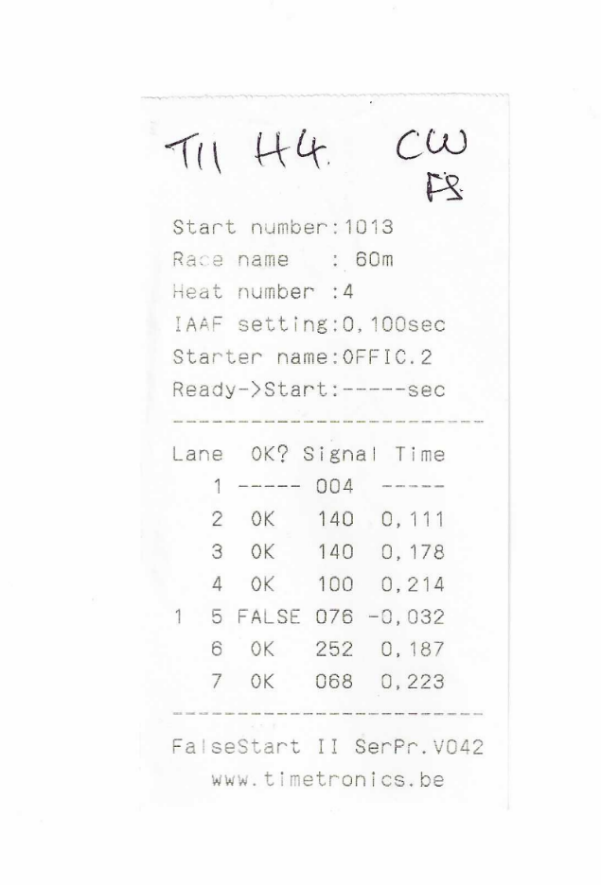
 | A | Lane 7 had the fastest reaction time
 | B | The athletes in Lanes 2 and 5 False Started
 | C | The athlete in Lane 5 moved but did not False Start
 | D | The athlete in Lane 5 False Started

16. |  | You are a Starter at a Regional Championships. Following a false start in a 400m race you ask for the athlete in Lane 3 to be disqualified. The athlete is not happy and claims to have heard a noise and will not leave the track. Do you … (1 mark)
 | A | Tell them they must leave the track as your decision is final and you will issue a conduct warning if they do not accept it
 | B | Ask the CSA what the problem is and change your decision to a Green Card
 | C | Ask the CSA what the problem is, establish with them and your team if they heard any noise if they didn’t then uphold your decision
 | D | Tell the athlete they can protest

17. |  | You are the Start Coordinator (SC). The athlete leaves the track, and the race is restarted without them. Afterwards the disqualified athlete approaches the Track Referee claiming to have evidence confirming a noise at the original start. The Track Referee refers the matter to you as the SC (There is no Start Referee). What do you do? (1 mark)
 | A | Say the race has already been run and the result is final
 | B | Say on hindsight you agree there was a noise but that as the race is finished there is nothing that can be done
 | C | Tell the athlete to make a protest
 | D | Consult with the Chief Starters Assistant (CSA) and your team and, as a result, accept there was an external disturbance. Advise the Track Referee that the start was not fair and discuss the possibility of a re-run

18. |  | You are the Starter at a County Championships where Para events are included. In a 200m Wheelchair race at what point do you start the race having said “set”? (1 mark)
 | A | When the athlete’s heads are lowered
 | B | When the athlete’s upper arms raise up on the main wheels
 | C | When all movement has stopped, and all athletes are steady
 | D | When the athlete’s upper bodies raise up

19. |  | You are the Starter at a County Championships where Para events are included. You are the Starter for an Ambulant 1500m. The race starts without issue but after approximately 20m, as the athletes move towards the inner lanes, you see one athlete fall to the ground, the race is well under way. What action would you take? (1 mark)
 | A | Do nothing as you consider the Start was fair
 | B | Recall the race and issue a sanction to the athlete you think was responsible for the fall
 | C | Recall the race and ask for a Green Card, no warning to be shown
 | D | Recall the race and ask the Track Referee if any athlete should be disqualified

Duty positions and practical questions

Answer the following question using the letters on the diagram showing a 100m start.

 | Question | Answer
20. | Where would the “block recall” be positioned?
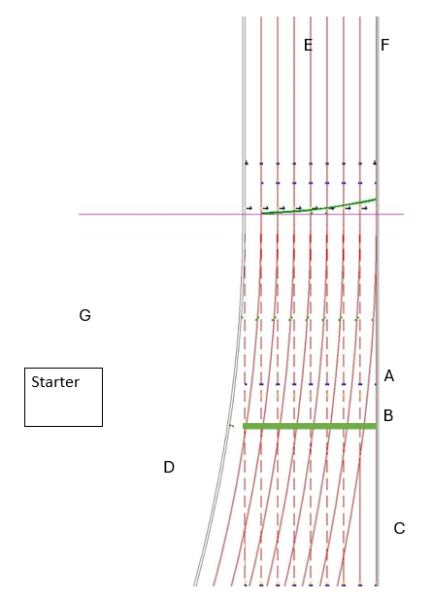

21. |  | You are working at a large middle-distance meeting, and the track referee has informed the start team there will be a split start for the 5000m. In a field of 24 athletes how many should be placed on the forward line?  (1 mark)
 | A | 12
 | B | 6
 | C | 5
 | D | 8

22. |  | All athletes have hip numbers from 1 to 24. Where should number 1 be positioned? (1 mark)
 | A | On the forward line on the outside of the track
 | B | On the forward line on the inside of the track
 | C | On the rear line on the outside of the track
 | D | On the rear line on the inside of the track.

23. |  | Other than standard checks what additional check should the Chief Starters Assistant (CSA) do before advising the Starter Assistants as the race is ready to go? (1 mark)
 | A | All athletes are in place correctly
 | B | The Clerk of the Course is happy the lane cones are in place
 | C | The starter is in position
 | D | The athletes have had a practice run out

 | Question | Answer
24 | Where would the starter be positioned?  (Answer using a letter on the diagram)

